Plot 95944:

- 12 additional abco in usfs df, two of which (in the usfs df) have dbh of 0.1 but the other small diamter observations are consistent between the dfs. These extra trees are also found in the raw USFS df.

- example of dbhs of some extra trees in the usfs df: 15.0, 15.0, 15.2, 18.0, 19.0, 20.0, 22.0

- p2veg_subplot_spp csv does not list other trees in the subplots

1st pic=filtered usfs data, 2nd pic=filtered raw data, 3rd pic=untouched raw data, 4th pic=original USFS data

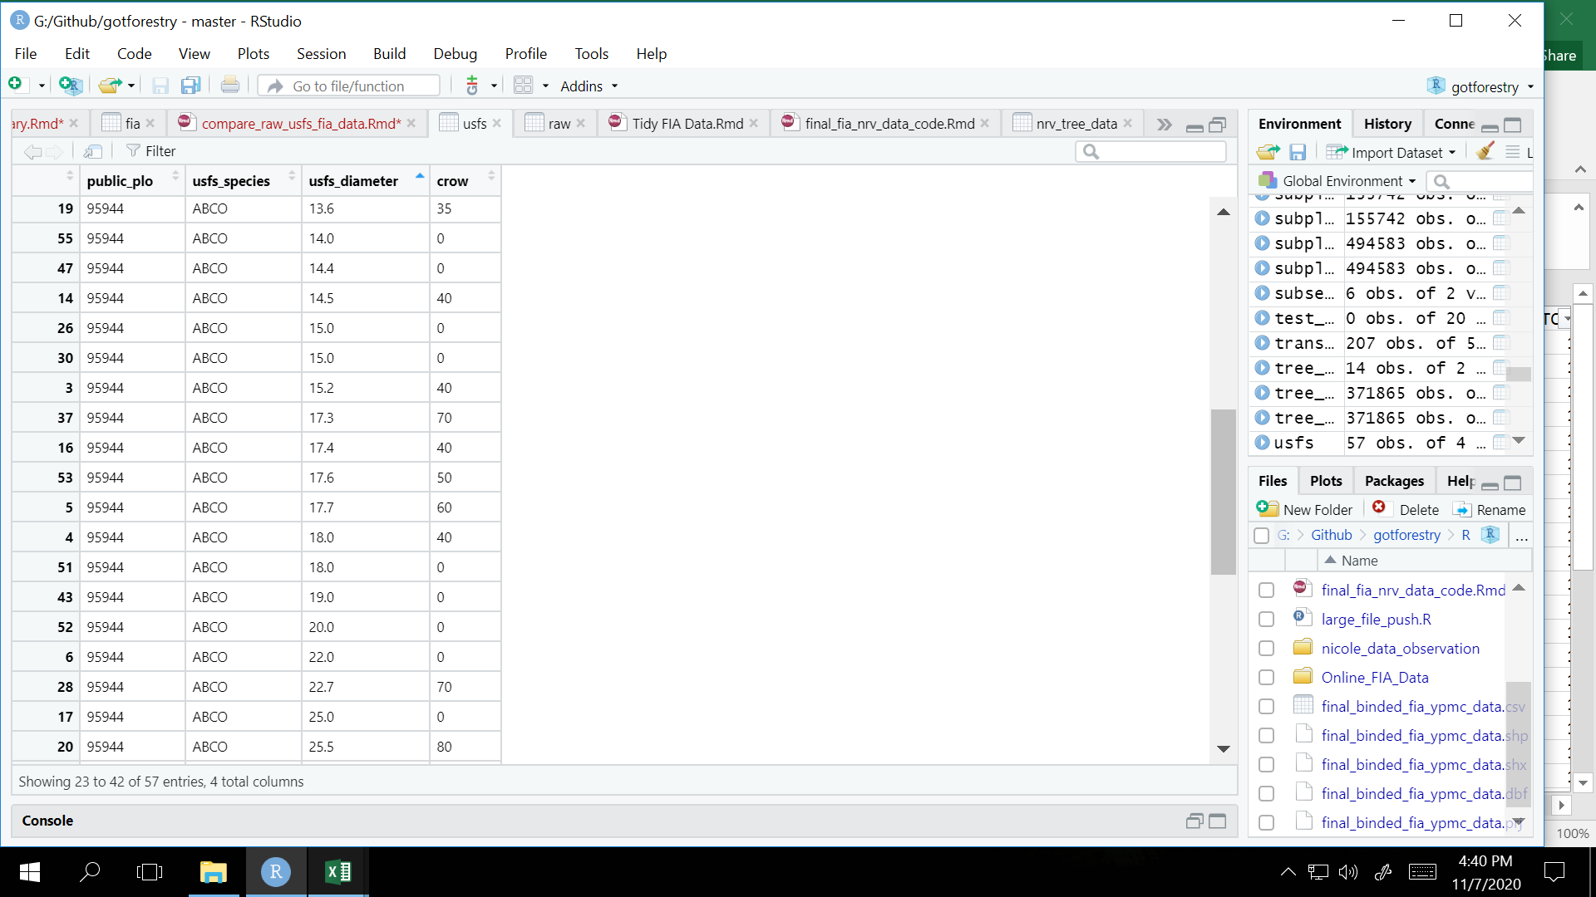

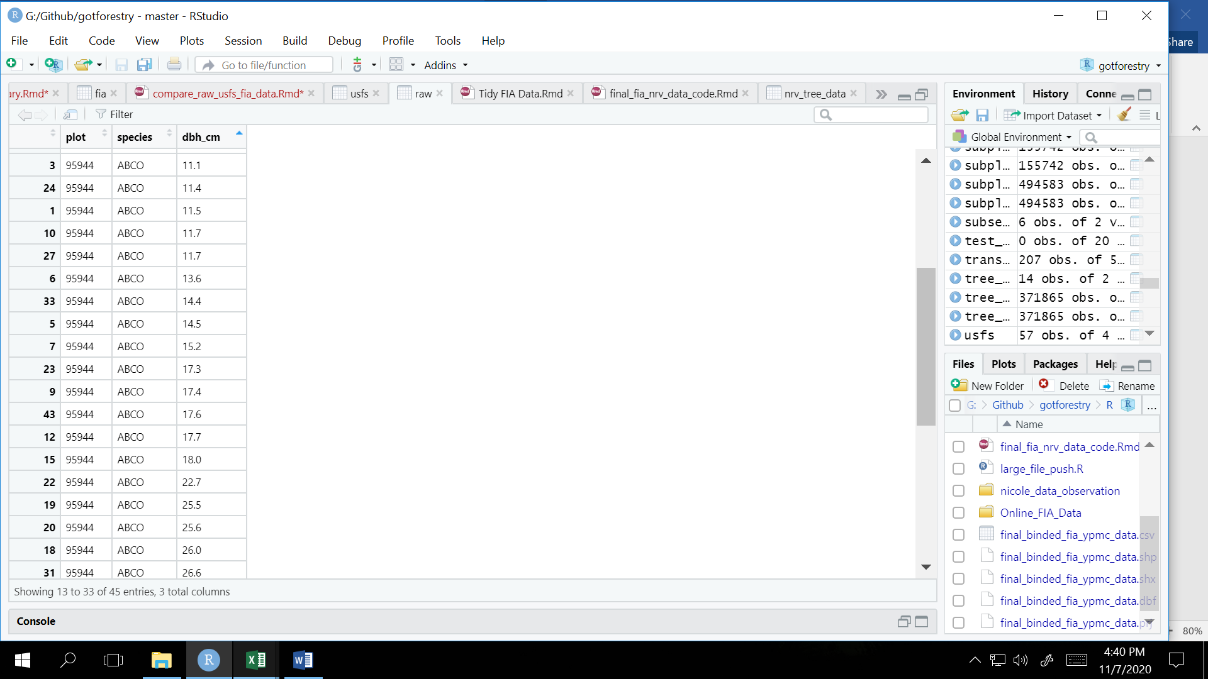

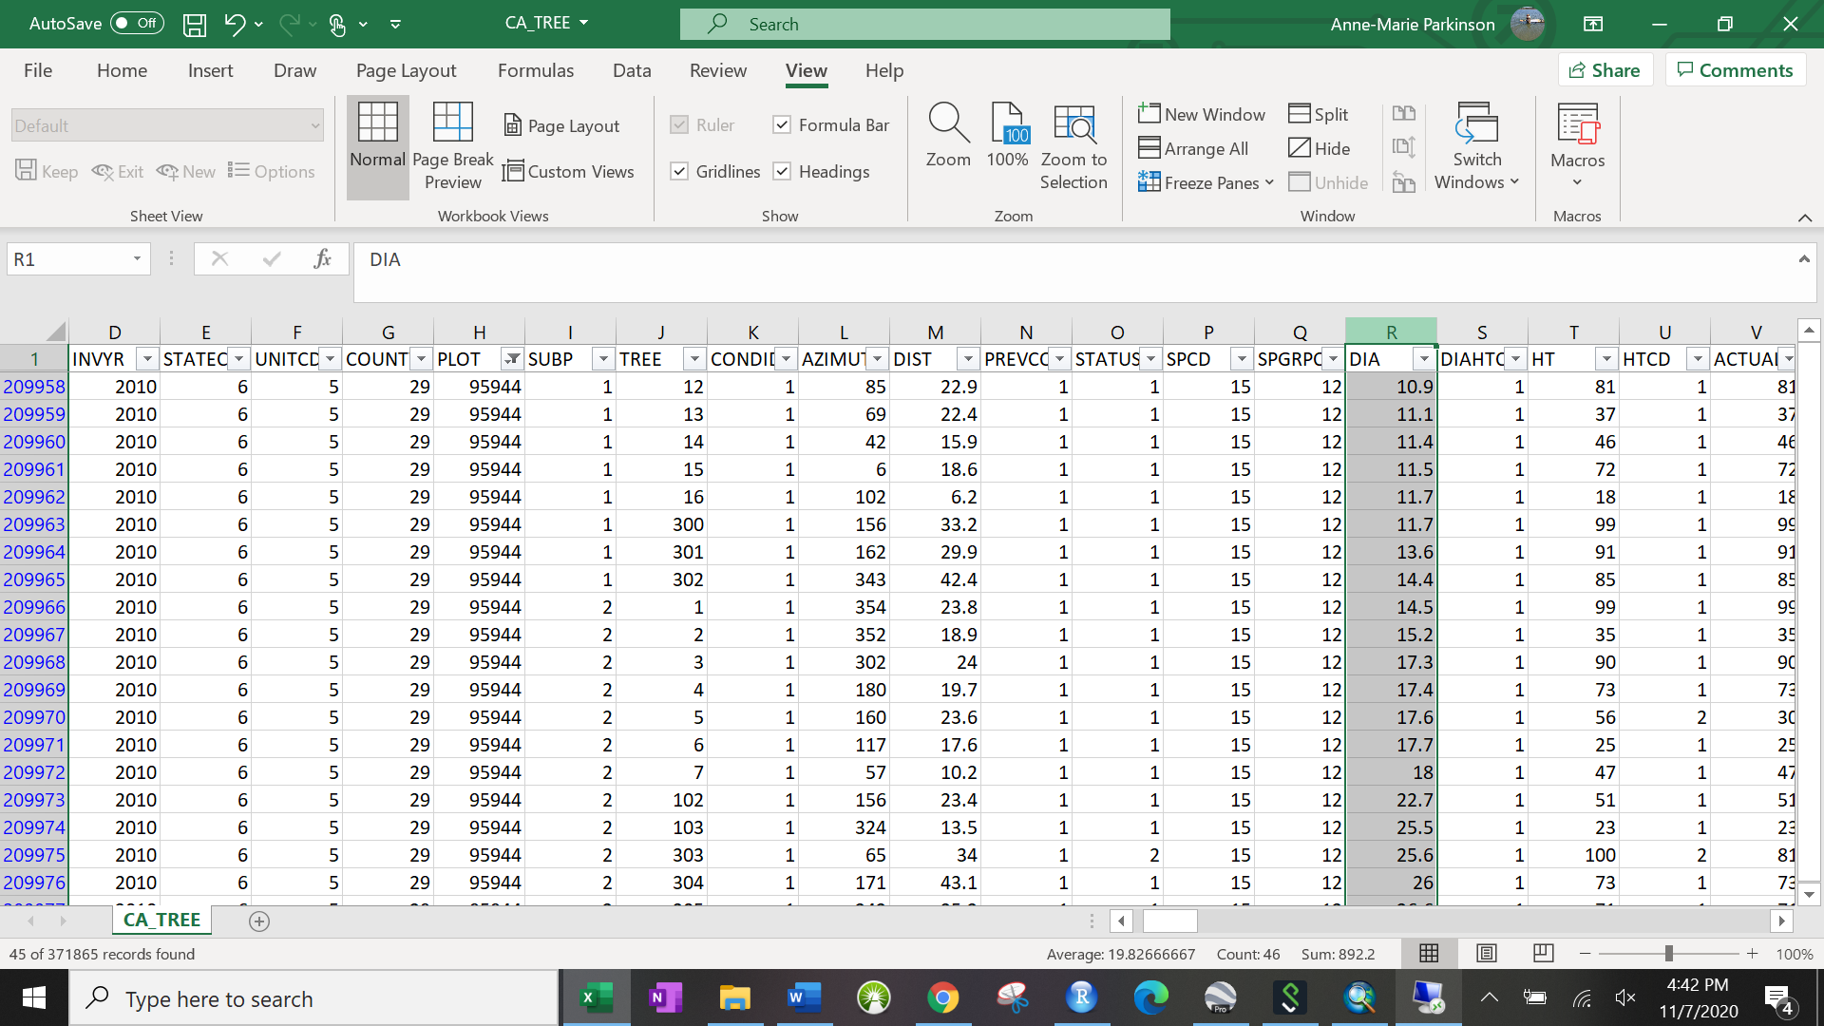

SPCD = species, 15 = ABCO

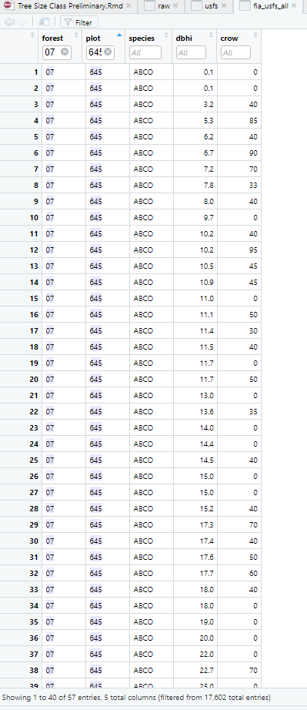

Plot 75717

- the years differ between the data frames. Online FIA =2001 and 2011 (both invyr and measyear have the same years of 2001 and 2011 recorded), usfs df=2008.

- AND the dbh's or # of species or # of trees do NOT match up. Basically there is a complete mismatch between the two dataframes

1st pic = abco and dbh in the filtered fia data from online, 2nd pic = unfiltered online fia data, 3rd pic = filtered usfs data of abco and dbh, 4th pic = raw usfs data

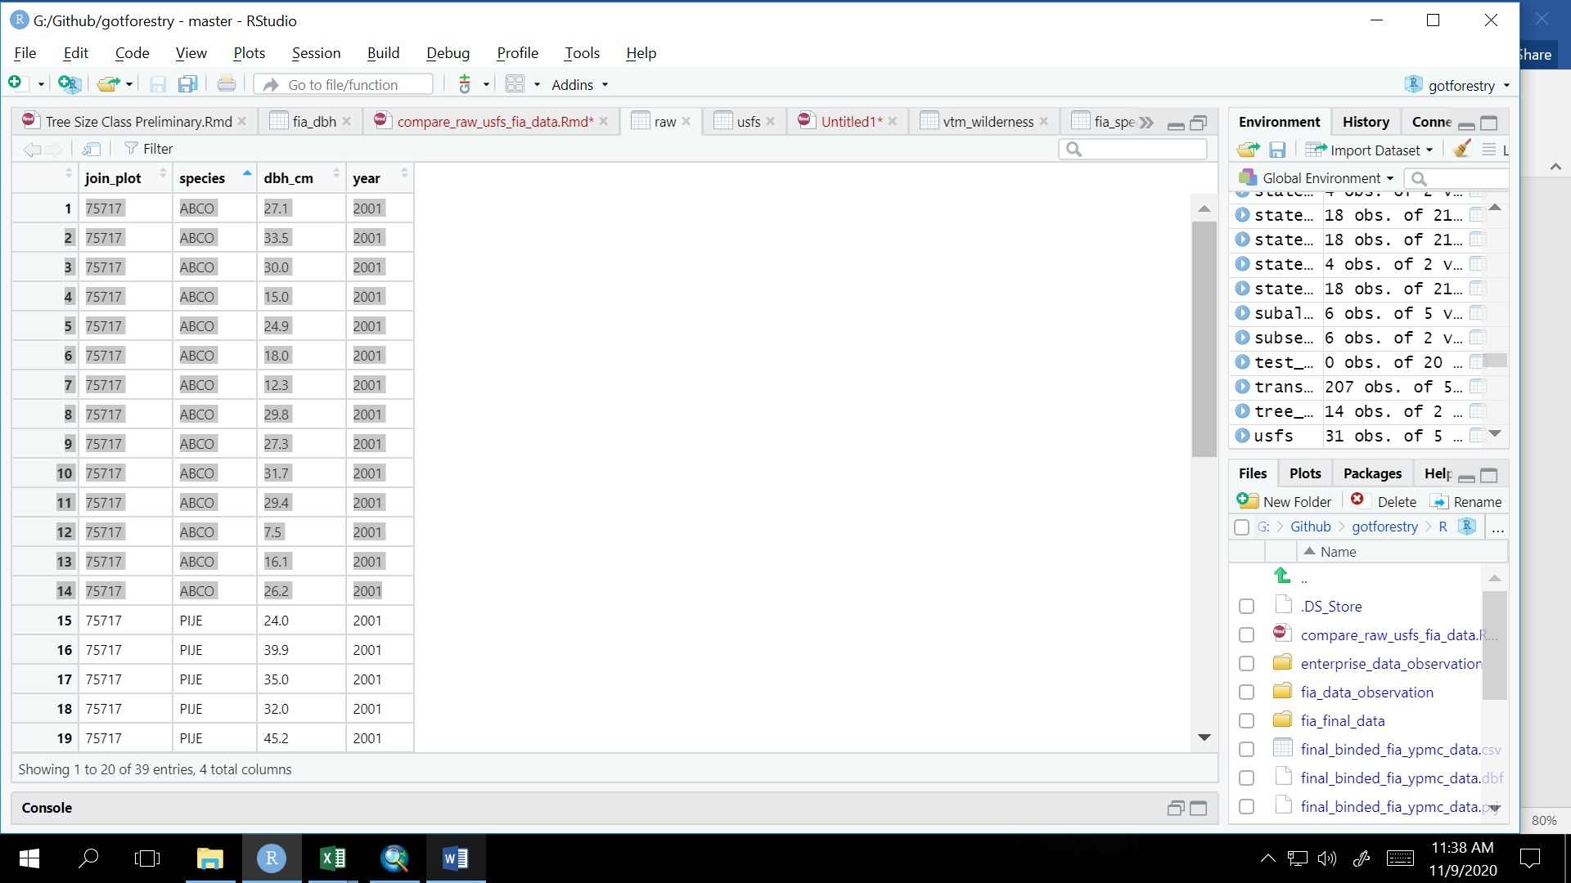

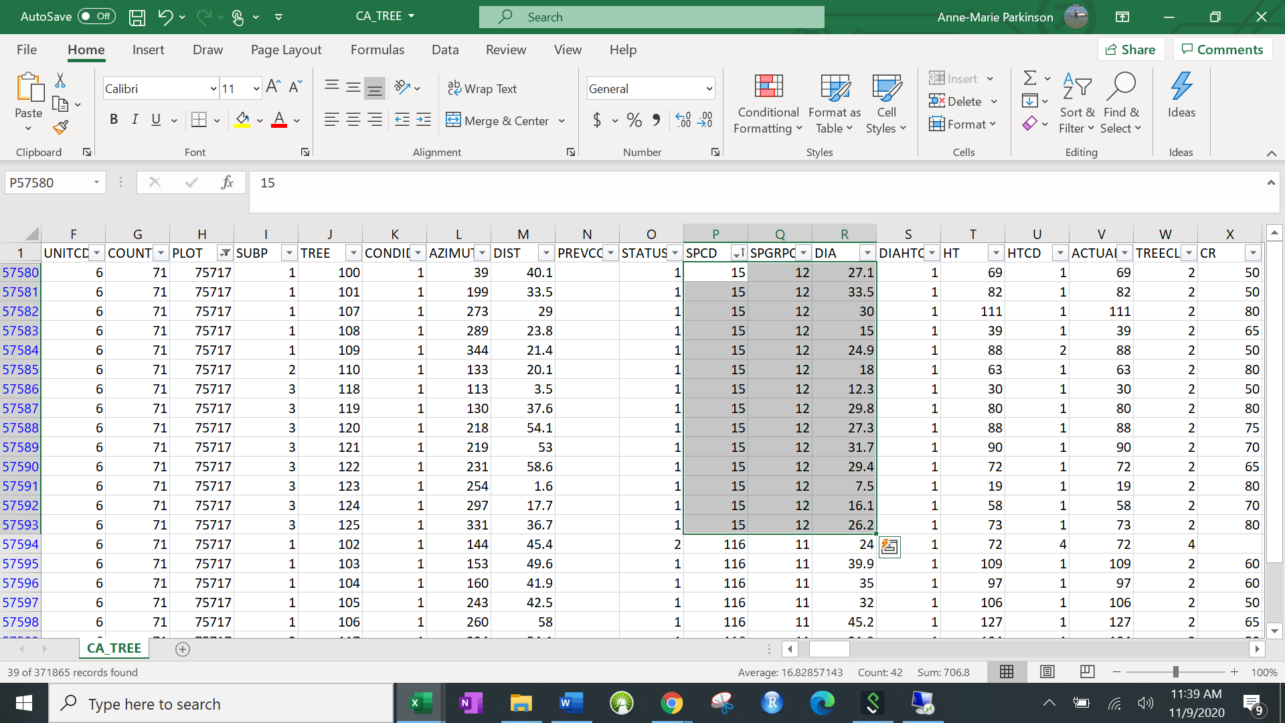

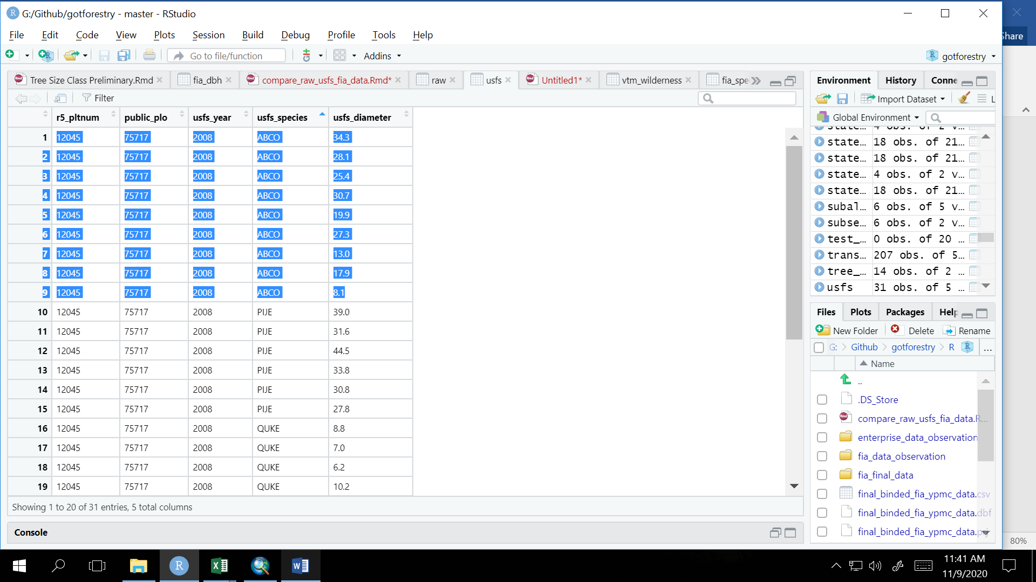

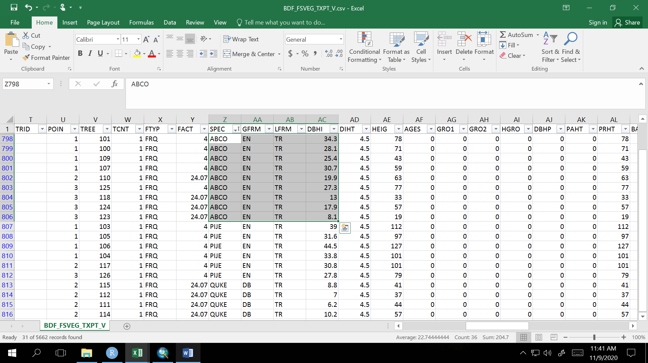

Plot 57680

- species, slope, aspect match up! :)

- Elevation was rounded up/down. :|

- 2 trees in the raw fia data are missing dbh but those trees in the usfs data hve dbh recorded (pije=17, abco=12). The same two trees can be found in the raw USFS data. The ca_trees.csv recorded the pije and abco as dead in 2003 and the diacalc column (See below) listed the dbh as 10.52 and 8.86, respectively. :(

diacalc: (from raw FIA metadata) Current diameter calculated. If the diameter is unmeasurable (e.g., the tree is cut or dead), the diameter is calculated (in inches) and stored in this variable. Only collected by certain FIA work units

1st pic=filtered usfs data, 2nd pic=filtered raw data, 3rd pic=untouched raw data, 4th pic = original USFS data

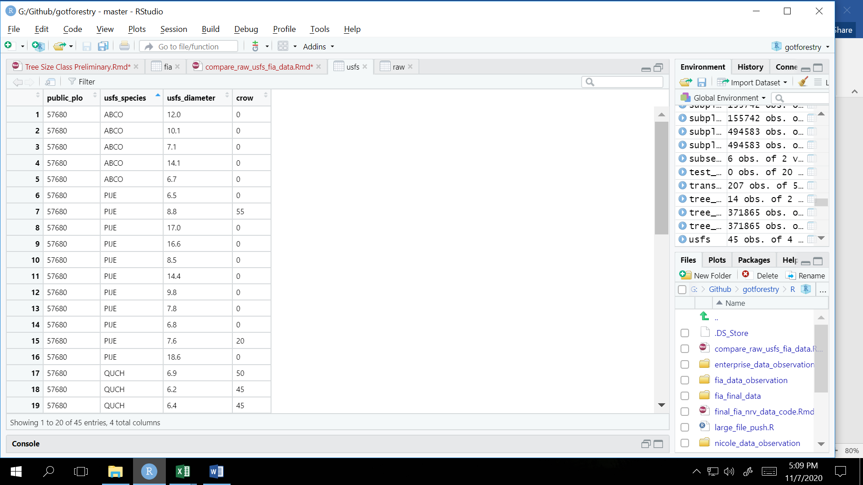

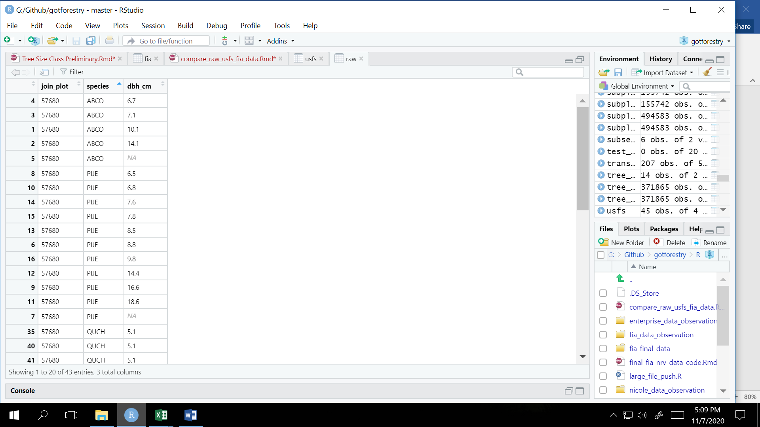

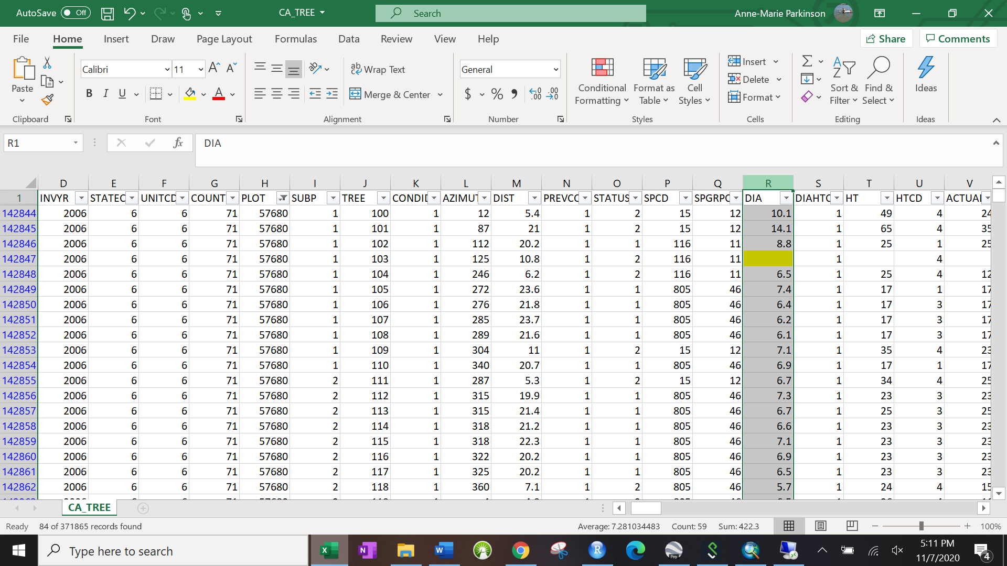

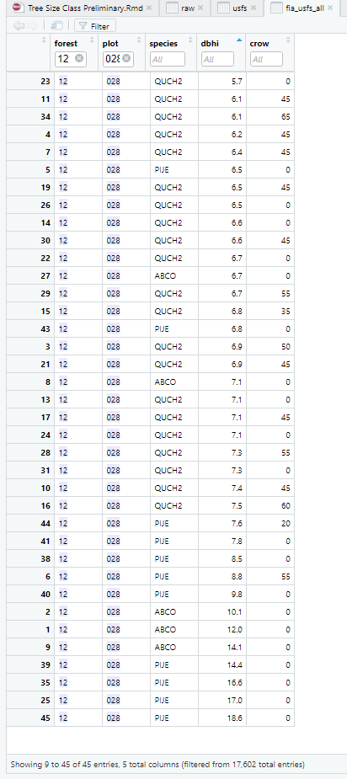

Plot 98648

- The filtered online fia data has 42 trees, while the filtered USFS data has 44 trees. The filtered USFS data has an extra ABCO of dbh 45.0 and another I (Jen) haven't found yet. The original USFS data has 44 trees.

1st pic: filtered USFS data, 2nd pic: original USFS data

